|  |  |  |
| --- | --- | --- |
| Assignment 6 | | |
| Classification | | |
| Student Name: saja eid aldosary | Section No: | Student ID :442050483 |

Use the breast cancer dataset at the link <https://www.kaggle.com/datasets/uciml/breast-cancer-wisconsin-data> to build a classification model using the data provided.

* Download dataset

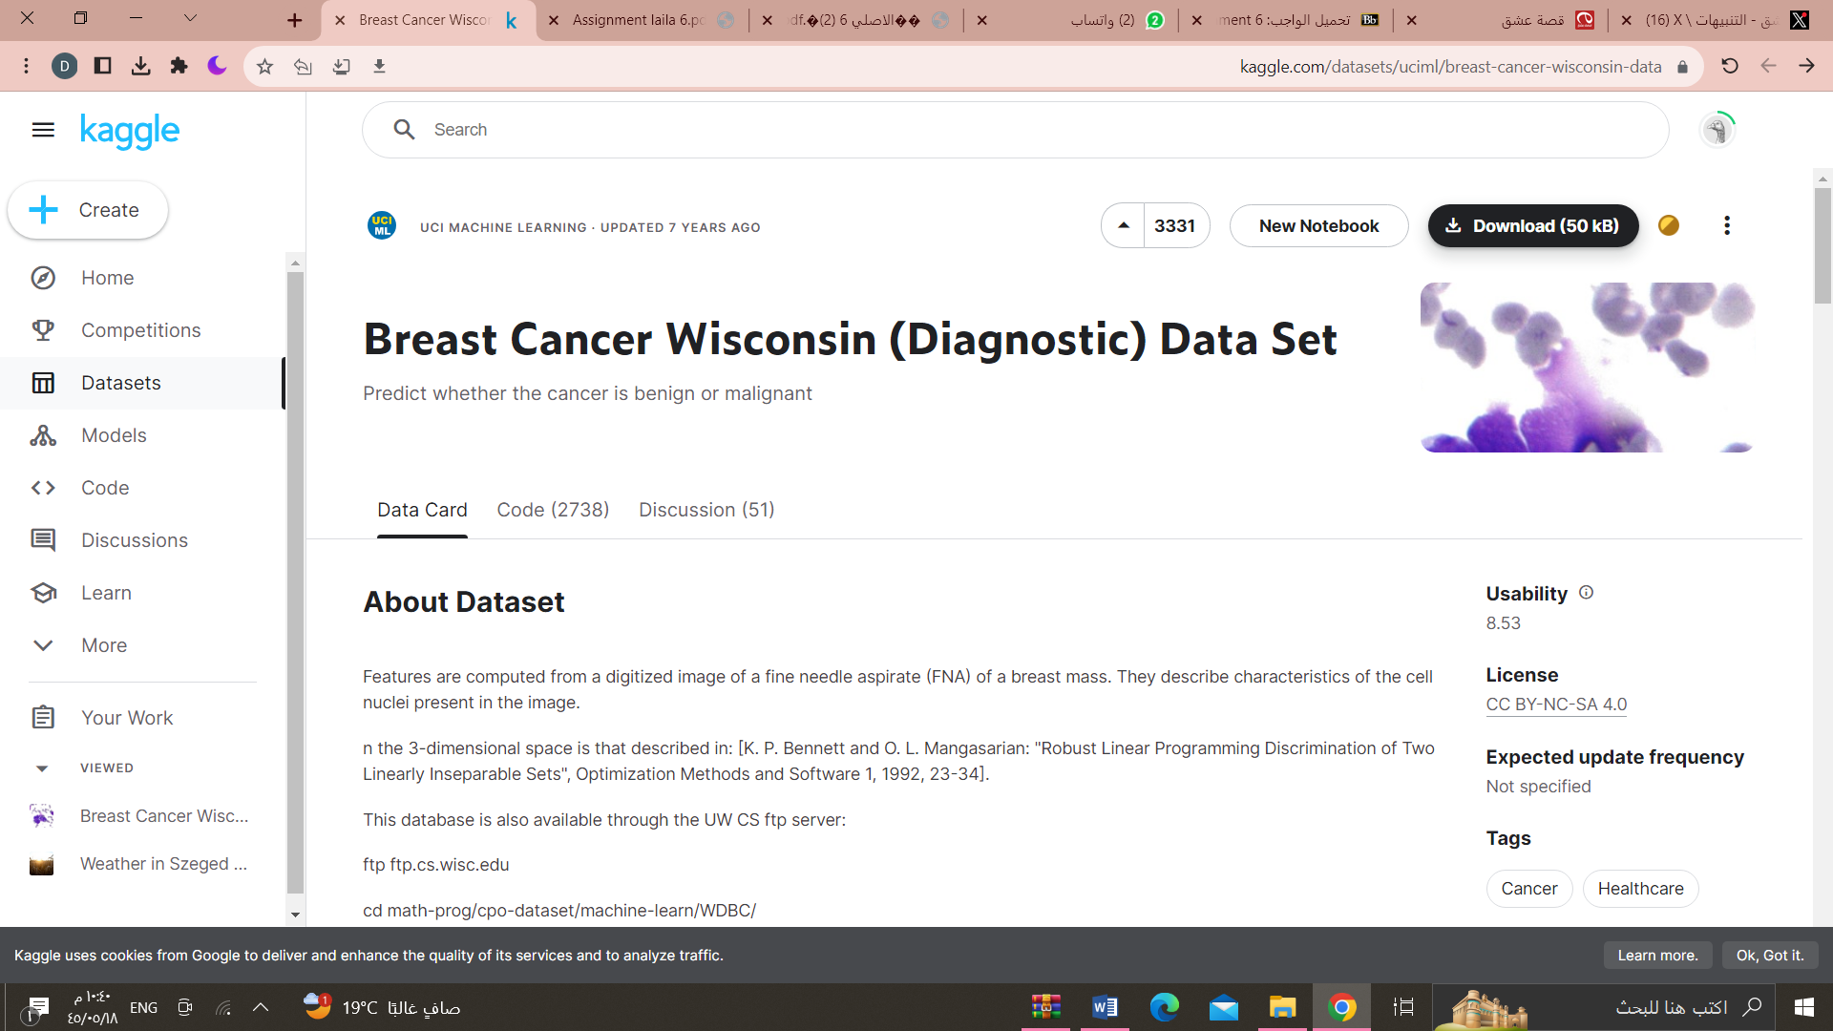

* Read the dataset
* import pandas as pd
* dataset=pd.read_csv("/content/data.csv")
* dataset.describe()

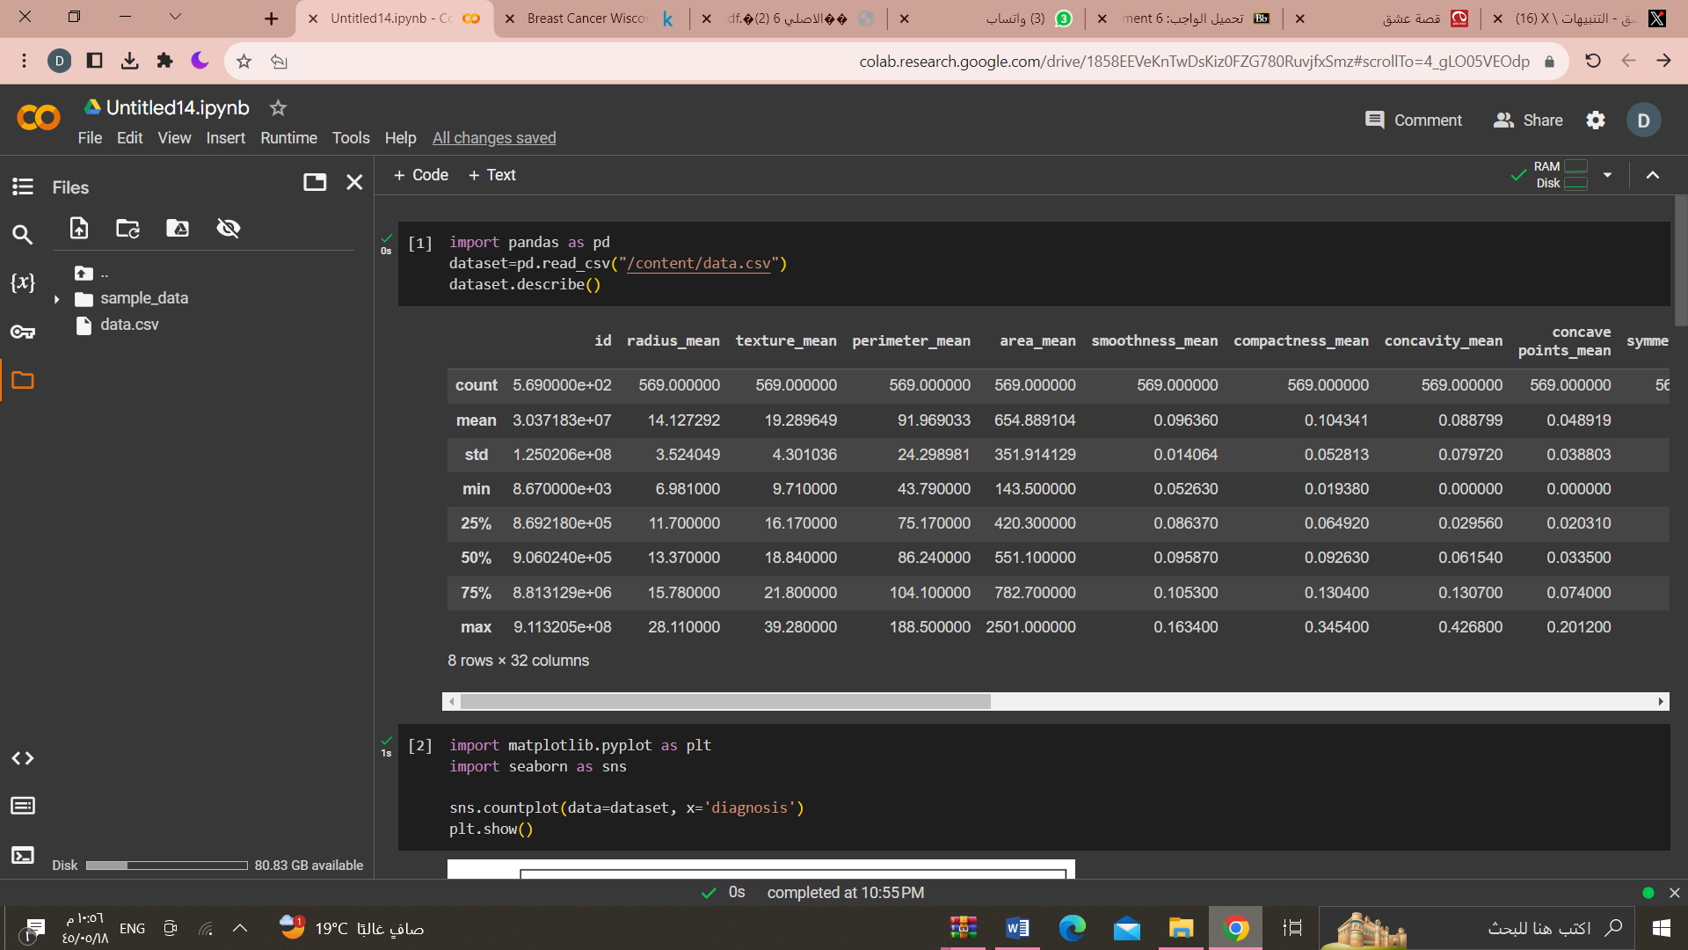

* Use visualization if possible.
* import matplotlib.pyplot as plt
* import seaborn as sns
* sns.countplot(data=dataset, x='diagnosis')
* plt.show()

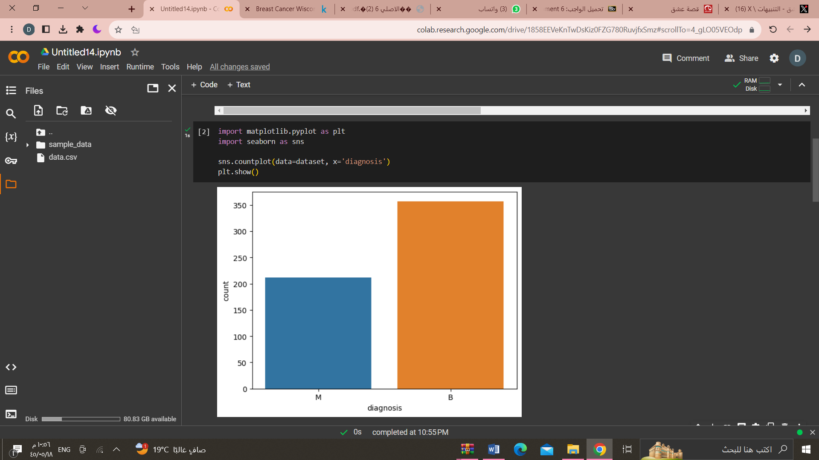

* Split the dataset 80% for train-20% for test
* import numpy as np
* from sklearn.model_selection import train_test_split
* from sklearn.linear_model import LinearRegression
* from sklearn.metrics import mean_squared_error
* X=dataset.drop('radius_mean', axis=1)
* y=dataset['id']
* X_train, X_test,y_train, y_test = train_test_split (X,y,
* test_size=0.2, random_state=42)
* print(X_train)
* print(y_train)

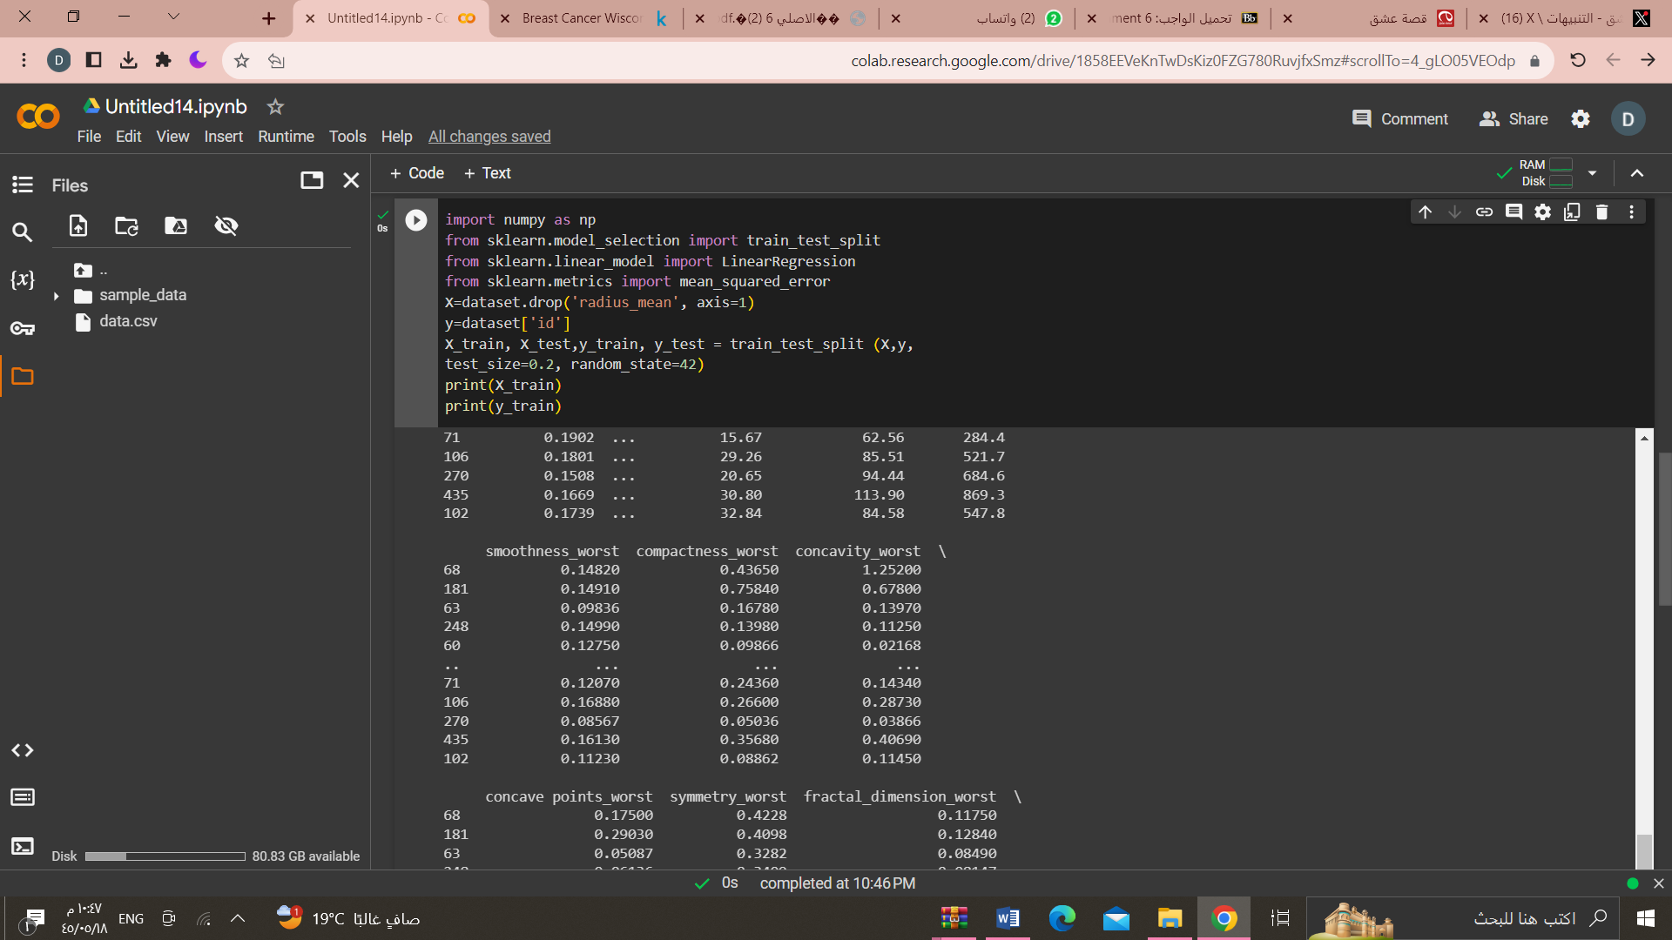

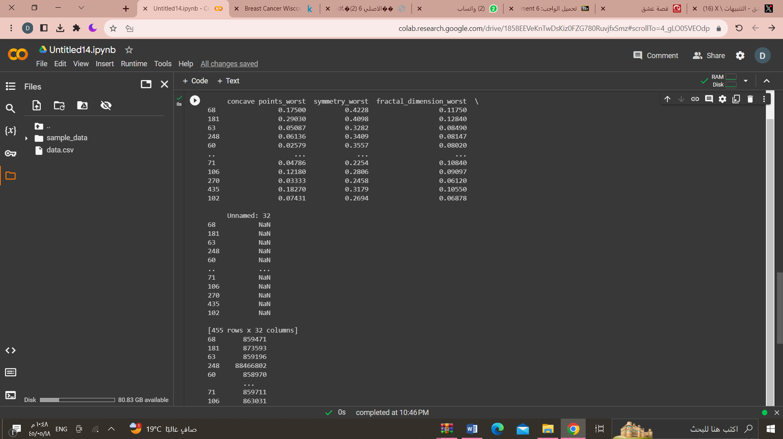

* Build the model using the train dataset split.
* X=dataset[['texture_mean','perimeter_mean']]
* y=dataset['area_mean']
* X_train, X_test, y_train, y_test = train_test_split(X, y,
* test_size=0.2, random_state=42)
* model = LinearRegression()
* model.fit(X_train, y_train)

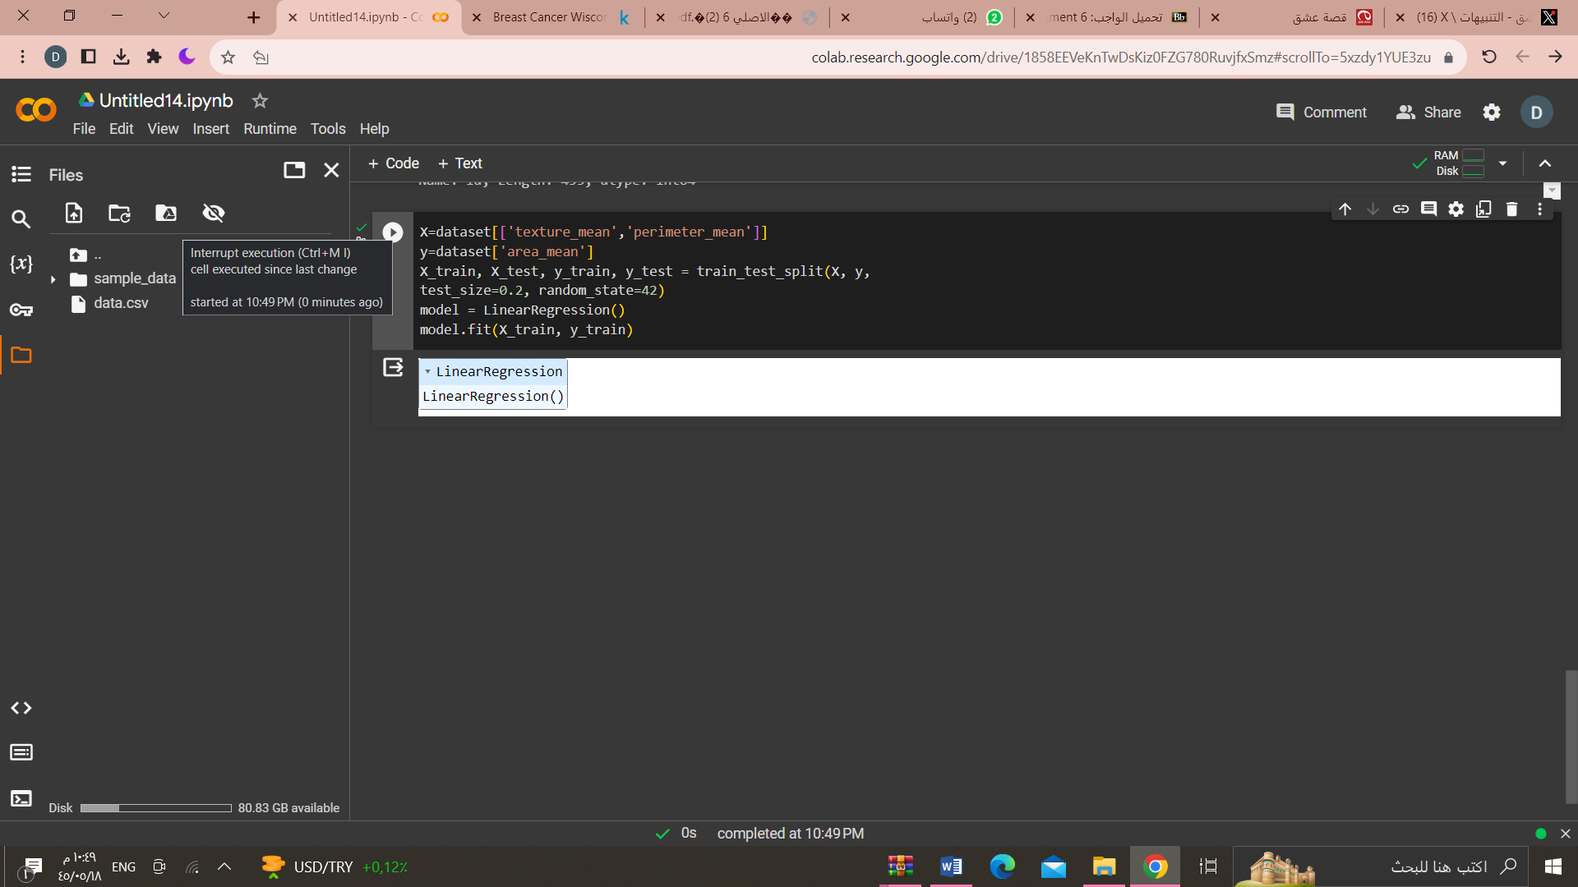

* Use the test dataset for evaluation.
* y_pred=model.predict(X_test)

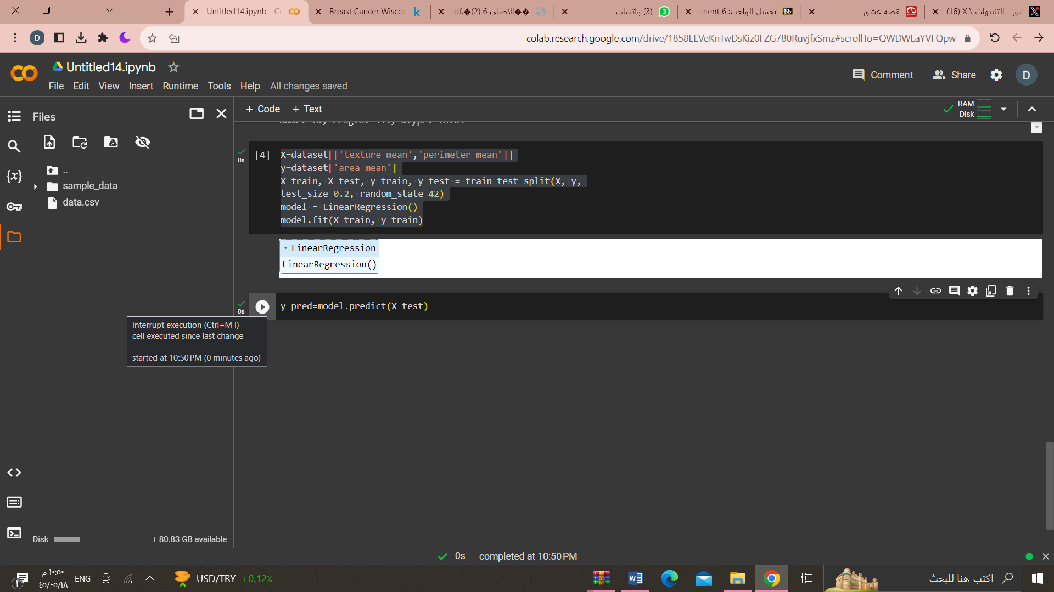

mse=mean_squared_error(y_test,y_pred)

print("mean squared Erorr:",mse)

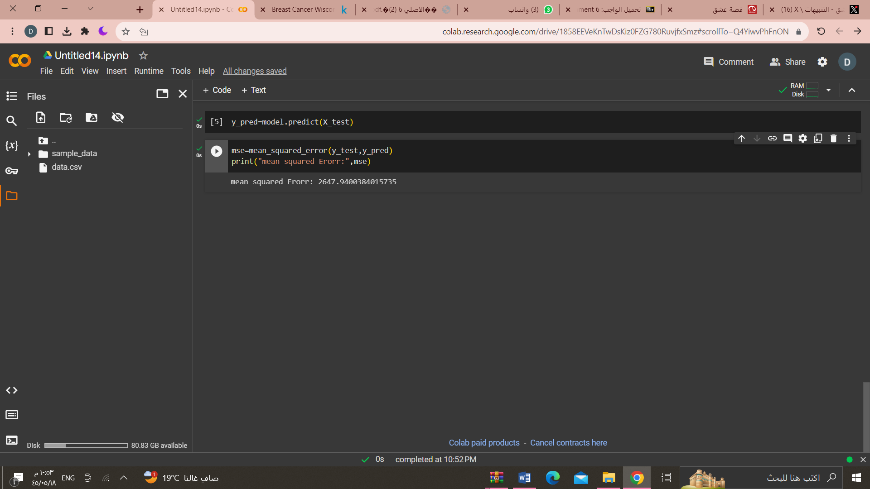

* Show the performance of the model.
* model.score(X_train,y_train)
* model.score(X_test, y_test)

